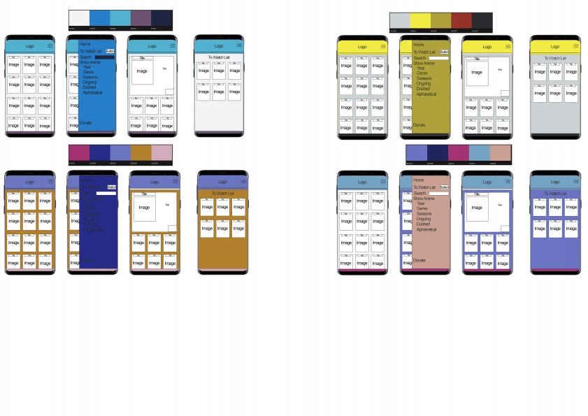



^{D} DesignCoourSceme
Thisdocumentwillbeusedtoshowcasecoloursthatwouldbebestsuitedforthewebsite,IamLookingatsimplecolour scheemethatwillbeapealingtowiderangeofusersbutalsousecoloursthataresuitableforcolourblindusersandusersthat havereducedvision.Iwillpickout3-5colourscheemesandthenusetheoneIlikethebest.Theönalcolourpalletandcolour layoutwillbeimplementedontheönaldesign.

